Incorporating Physical Co-presence at Events into Digital Social Networking
Scott Counts  Microsoft Research  One Microsoft Way, Redmond, WA 98052  counts@microsoft.com  +1-425-882-8080 | John Geraci  New York University  721 Broadway, New York, NY 10003  jbgeraci@yahoo.com

ABSTRACT

Copyright is held by the author/owner(s).
CHI 2005, April 2–7, 2005, Portland, Oregon, USA.
ACM 1-59593-002-7/05/0004.

As mobile devices become location-aware, it will become possible to know when people are physically co-located and to incorporate this information into social software. Is this valuable? A prototype social networking system based on physical co-presence was created and tested wizard-of-oz-style at four different physical social events by providing event attendees a digital link back to others at the event. Usage of the system was higher than expected, suggesting a meaningful role for incorporating shared physical events into social networking software. Usage and questionnaire analyses suggest some guidelines for design of such systems.

Author Keywords
Social computing, social networking, events, mobile computing.

ACM Classification Keywords
H5.3. Information interfaces and presentation (e.g., HCI): Group and Organization Interfaces.

INTRODUCTION
Computing systems supporting social networking have become popular in recent years. Most are web-based systems that allow users to expand their social networks by searching for people with matching profiles, with search distance in the network often constrained by the “friend of a friend” algorithm. As we move into an era in which social computing is more integrated into our daily lives, social software can augment our physical social interactions, giving rise to hybrid virtual-physical systems in which social networking systems incorporate people met at the various social events we attend. As such hybrid systems are developed, it is important to test for their benefits. The primary contribution of this paper is an assessment of the value and usage of a social networking system based on common attendance at a physical social event. Given a system that allows us to extend connections with people made through ad hoc social encounters, to what extent and in what ways will people use it?

BACKGROUND
Social networking has become an important part of social computing and well-integrated into the mainstream, with a wide array of social networking systems having sprung up in recent years, both within (ReferralWeb [7], Wallop [4]) and outside (Tribe [14], Orkut [11]) the research community. Social networking systems do however have some problems. As described in a recent ethnographic study of Friendster [1], perhaps the most well-known social networking site, the way the self and the social network are represented digitally often make important interpersonal functions, such as contextualized self-presentation, difficult. Integrating the digital social network with physical events might alleviate some issues. In the case of self-presentation, for example, a physical social event provides context for self-presentation that can then serve as the cornerstone around which relationships can be built in a digital system.
Although most social software is divorced from physical social interactions, we are starting to see some integration of the two. Systems such as Swarm [5], Dodgeball [3], and Social Net [13] are mobile device-based systems that help friends coordinate social activities and meet friends of friends in close proximity. Electronic name badges, such as nTag [10] and SpotMe [12] facilitate communication and interaction at conferences. Large public displays are also being used [2,6,8] to support awareness, information dissemination, and social interactions in physical spaces.
Perhaps the best example of integrating social networks with physical co-presence is Meetup [9]. Meetup is a web-based system that helps people with similar interests, such as political party affiliation or owners of a breed of dog, meet one another and organize events. Meetup starts with people of similar interests and helps organize events for them. In contrast, the type of system tested in this research starts with a social event, and based on the assumption that the people who attend the same events have similar interests, provides a mechanism for people to connect with one another after the event.
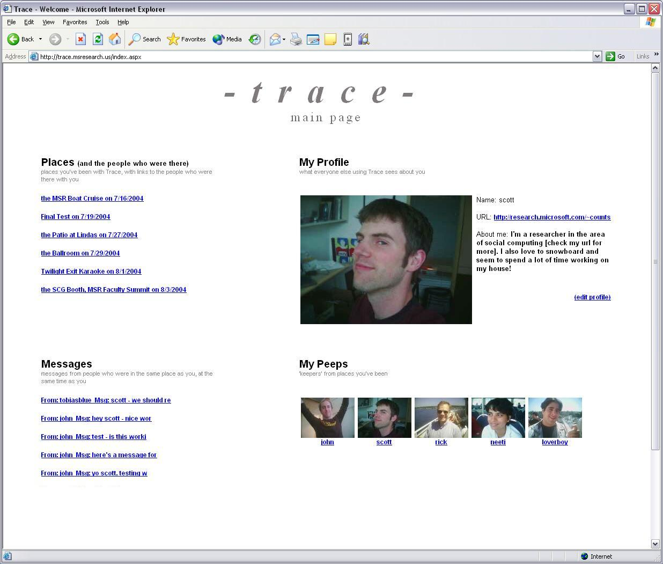
Figure 1: Example Trace index page

TRACE
To test this concept of social networking based on physical social events, a web and email-based prototype social networking system called Trace was created to allow people that attended the same event to follow up with one another after the event. The basic experience of using Trace involved attending an event, receiving an email the following day containing photos and links to profile pages of the other people from the event, then optionally viewing these profiles, contacting any of these people, and updating one’s own profile page.
The main web page for each person was their index page (Figure 1) listing events attended. Clicking an event would show photos of other people from the event that were in turn clickable to each person’s profile page. Profiles contained photos and optional ‘about me’ statements and blog urls. Each person could keep a list of their ‘peeps’ or people from events attended that they had specifically saved as favorite people. Messages could be sent through Trace that were also sent to the recipient’s email.

EXPERIMENTAL FIELD STUDY
An experimental field study was conducted to assess usage. Questionnaire data were also collected to assess users’ subjective experience.
Users were recruited at four different informal events, two ‘nights out’ at local bars, a karaoke contest, and a poetry reading. A total of 66 participants provided valid contact information, breaking down to 9, 10, 22, and 25 people from the four events, respectively (average = 16 people per event). From the two events with fewer people, roughly 10-15% of the total people at the event were recruited into Trace. For the other two events, roughly one third of the total people at the event were recruited into Trace.
The authors approached people at each event, briefly explained the project and asked if they would like to participate. If they did, a photograph of them was taken for their profile, they chose a user name, and optionally provided an ‘about me’ statement and URL to their blog or web page of their choosing. Participants that knew one another prior to using Trace were noted has such.
Participants did not have to explicitly provide their age, but all participants appeared to meet the target demographic age of 18 to 40. Gender was balanced to the degree possible, with 29 men and 37 women.

Results

Usage
The day following an event, users received email containing photos and links to other event attendee’s Trace profile pages. Users were free to use the system as much or as little as desired. Table 1 shows primary usage data. This is the most conservative presentation of the data, with a number of data points removed. Interactions between people who knew one another prior to the event were removed. Also, these data points reflect unique usage, so repeat profile or message viewings have been removed.
50% of participants used at least one feature in Trace at least once. As one would expect, viewing profiles was by far the most heavily used feature. Of people who actually used Trace, on average more than 8 unique profiles were viewed, .40 messages sent, and .50 peeps added.
 | All | Prof view | Msg Sent | Msg View | Msg Repl. | Peep
Tot. | 325 | 273 | 13 | 12 | 3 | 17
% Use | 50 | 45 | 14 | 14 | 5 | 12
Avg/ Pers. | 9.8 | 8.3 | .41 | .36 | .09 | .52
Table 1. Primary usage of event-based system, only interactions with users unknown to one another prior to the event: total count of each feature, percent of people that used each feature, and of those people, the average uses per person.
Of the four events, two were larger in terms of the number of people from the event we were able to capture in Trace. From the smaller events, less than 20% of the people used Trace, with only one message sent and no peeps added. In contrast, 59% and 68% of people from the two larger events used Trace. On average, half of these people sent messages (.52 messages per person) and added Peeps (.6 Peeps added per person).
Given the tie to informal events and to evolving social schedules, of interest is the lifetime of social interactions surrounding an event in an event-based social networking system. The pattern of usage over time (Figure 2) was quite similar at each event. The vast majority of usage took place the day after the event, then flattened out 3 - 5 days after the event, and ended 6 - 9 days after the event.

Questionnaire Responses
17 people responded to a voluntary follow-up survey. The primary results highlighted three issues:
- Making new contacts: Of 6 reported new contacts made through Trace, 3 were people met at the event, 3 were people noticed but not actually met.
- Connectedness: Participants reported weak to mild connectedness to other people at the events (2.6 average on a 7-point scale where 1 was not connected and 7 was strongly connected).
- Additional usage scenarios: If Trace profiles were available before and during an event, roughly half of respondents reported they would use Trace profiles to see who was going to or was at an event, particularly to decide who to talk to. Contacting event attendees and coordinating transportation would be used by only a quarter to a third of participants.

Interactions
Examining the messages sent using Trace gives a flavor of the type of interactions people had using the system. Given the common theme of the event, a number of messages took into account the physical venue of the event itself. For example, one person used the physical location as a reference point for potential future interactions: “Too bad we didn't get to talk more, you ran off. I'll look for you next time I'm around that way. Have a great weekend!” Other messages referred to interactions the two people had at the event, such as, “That was fun, we will have to come up with an adventurous thing to do sometime soon.” Several messages were humorously apologetic for a person’s behavior at the event: “Hey, sorry if I came off as an ass the other night I was a wee bit intoxicated ;)”
Figure 2: Usage over time for karaoke event, all users. Shown are number of profiles viewed, number of messages sent, and number of peeps added.

Some exchanges between people who met at the event or afterward through Trace were simple notes without an expectation for further follow-up. For example, one person wrote another to say “I added you to my peeps cause I see you all the time and also you rock.” A few of the exchanges between people meeting one another highlighted the core Trace scenario of providing a spring-board communication channel for follow-up after an ad hoc social encounter. “Anyways give me a call whenever you want to hang out and maybe grab some coffee?” In perhaps the best example, after several exchanges, one person wrote, “BTW what is your email address / AIM name?” and then provided his or her email and instant messaging contact information.

DISCUSSION and Conclusion
As social software becomes more integrated with ever more capable mobile devices, social networking software can begin to augment our existing physical world social interactions. Such a system has the advantage of capitalizing on shared experience as an important social connector in order to migrate interesting and meaningful ad-hoc social encounters to longer-term relationships.
A web and email-based system was created that allowed people at informal social events to view and follow-up with one another. Usage of the system was higher than expected, with half of all possible people using the system. Usage and questionnaire analyses suggested some guidelines for development of event-based social networking systems:
Support Quick Turnaround Usage over time showed that the “mental lifetime” of an informal event does not appear to be more than a few days to one week. Thus, of utmost importance is providing users with connections to the people from an event as quickly as possible after the event.
Attain Critical Mass Of the four events studied, the two with more people entered into the system were much more successful, underscoring the need for a system to have a critical mass of event attendees. Simply as a matter of maximizing the odds of any given person using the system to follow-up with another specific user, a critical mass of people must be in the system. For logistical efficiency, this suggests localizing the system to people’s mobile devices as a means of distributing the data capture.
Do Not Rely on Peer-to-peer On the other hand, the questionnaire results indicated that connections were made between people who did not interact at the event. This means that close range peer-to-peer systems may not suffice. Use of GPS or RFID or bluetooth scanning at the event entrance for automatic location logging might solve this problem.
Possible use for profiles before and during an event The questionnaire results suggest some usage and benefit of social network profile availability before and during an event, particularly for deciding who to talk to at an event. Future work might address this more specifically.
Another area for future work might be an examination of how usage of event-based networking systems varies with different event types. Simply being in the same place at the same time as other people does not necessarily engender a sense of connectedness or community amongst the people there that would generate usage of an event-based social networking system. A number of variables, including physical characteristics such as event size, place, and the demographics of those attending, but also social psychological characteristics such as the degree of perceived self-identification with the event or with the type of person attending the event might play a role.
Clearly, the method of input for such a system needs working out. The tension between the practical convenience of a distributed system on mobile devices and the necessity of connecting people that did not necessarily interact face to face at the event requires resolving. The aforementioned scanning system at event entrances is one possibility, although one that requires an extensive hardware infrastructure. Another is to pool together all pairs of people logged in close proximity to one another via peer-to-peer connections. Although GPS faces connectivity issues in urban areas, it might be used to log all people in a location over a specified time period.. The different input methods must address both common and unique privacy concerns.
Overall, usage was not unlike physical social interactions at informal events. A sizeable percentage of interactions take place between previously unknown people that are simple, light exchanges, and occasionally a more meaningful social connection is made. Social software that augments this process can provide additional opportunities for follow-up or for connecting with people missed at the event itself.

ACKNOWLEDGMENTS
We thank Debbie Warnock and Ron Goldin for assistance with data collection, Lili Cheng for her design feedback, and Shelly Farnham for her feedback on study design.

REFERENCES
- boyd, d.m. Friendster and Publicly Articulated Social Networking. In Proc. CHI2004, ACM Press (2004), 1279-1282.
- Churchill, E.F., Nelson, L., Denoue, L., Helfman, J., and Murphy P. Sharing Multimedia Content with Interactive Public Displays: A Case Study. Proc. DIS 2004, ACM Press (2004), 7-16.
- Dodgeball. http://www.dodgeball.com
- Farnham, S., Kelly, S.U., Portnoy, W., & Schwartz, J.L.K. Wallop: Designing Social Software for Co-located Social Networks. In Proc. HICSS-37 (2004).
- Farnham, S., Keyani, P. Swarm: Smart Convergence and Peripheral Social Awareness. Paper presented at HCIC 2004, Winter Park, Colorado.
- Greenberg, S. and Rounding, M. The Notification Collage: Posting Information to Public and Personal Displays. Proc. CHI 2001, ACM Press (2001), 514-521.
- Kautz, H., Selman, B., and Shah, M. ReferralWeb: Combining Social Networks and Collaborative Filtering. Communications of the ACM 40, 3 (1997), 63-65.
- McCarthy, J.F., Nguyen, D.H., Rashid, A.M., and Soroczak, S. Proactive Displays & The Experience UbiComp Project. SIGGROUP Bulletin, 23, 3 (2002), 38-41.
- Meetup. http://www.meetup.com.
- nTag. http://www.ntag.com.
- Orkut: http://www.orkut.com
- SpotMe. http://www.spotme.info.
- Terry, M., Mynatt, E.D., Ryall, K., and Leigh, D. Social Net: Using Patterns of Physical Proximity Over Time to Infer Shared Interests. Ext. Abstracts CHI 2002, ACM Press (2002), 816-817.
- Tribe: http://www.tribe.net

