Linking Public Spaces: Technical and Social Issues
Gavin Jancke, Gina Danielle Venolia, JJ Cadiz,
Jonathan Grudin, Anoop Gupta

September 21, 2000

Technical Report
MSR-TR-2000-93

Microsoft Research
Microsoft Corporation
One Microsoft Way
Redmond, WA 98052

Linking Public Spaces: Technical and Social Issues

Gavin Jancke, Gina Danielle Venolia, Jonathan Grudin, JJ Cadiz, Anoop Gupta
Microsoft Research
One Microsoft Way
Redmond, WA 98052-6399
{gavinj;dvenolia; jgrudin;jjcadiz;anoop}@microsoft.com

ABSTRACT
Three public spaces frequently used by members of a single organization who are distributed across different floors of two buildings were linked by constantly-running video and audio connections. We discuss the design of the system, including issues in providing low-latency full-duplex audio-video connectivity, ways to increase possibilities for interaction while addressing privacy concerns, and the introduction of the system to the community. We report on responses to the system and lessons learned, including unexpected issues, such as creative decorations of the spaces and assertions by a vocal minority of employees about the private nature of “public space.”

Keywords
Informal communication, videoconferencing, privacy

INTRODUCTION
The value of informal interaction in workplaces is widely recognized and was convincingly demonstrated by studies of workplace collaboration at Bellcore in the 1980s (Kraut et al., 1990). As distributed work has become more widespread, it was natural to determine whether some of the digital technologies that make work distribution possible might not also facilitate informal interaction on a scale beyond casual email. Accordingly, the use of audio and video to support informal workplace interaction has been a strong focus of human-computer interaction research since the late 1980s.
Before reviewing relevant prior research, we will illustrate the appeal of the technology by describing the motivation for our system. Our organization of approximately 400 researchers and support staff moved from a single building of three floors with a central open atrium and stairway to two adjacent buildings with four floors each and a number of peripheral stairwells. We had overcome crowding, but casual encounters were far fewer.
To promote informal social interaction, four activities are in place, all centered around free food. They are an annual picnic, a monthly Friday afternoon social event, a weekly Wednesday mid-afternoon break with snack food, and our experimental system, a continuously running audio and video link between three of several “kitchens” where employees have always been able to help themselves to free soft drinks, coffee, and tea.
The previous building had three kitchens, each serving over 100 people. Now there are seven on different floors of the two buildings, each servicing about 75 people. This reduces the number of chance encounters. We hope to improve the odds by linking them with audio-video connections, starting with three as a trial.
After reviewing prior research, we will describe our system, report on usage data and a survey, and identify a range of technical, behavioral, and social issues that were encountered. We conclude with lessons learned and directions for further inquiry.

OVERVIEW OF PAST RESEARCH
Many early studies of video support for informal interaction focused on desktop systems (e.g., Root, 1988; Dourish and Bly, 1992; Fish et al., 1992; Gaver et al., 1992; Tang and Rua, 1994). Computers were appearing on desks but were generally considered too expensive to be devoted to purely informal interaction. Some systems that were primarily for desktop videoconferencing included one or two views of public spaces such as a coffee kitchen, lecture room, or outdoor scene. These public spaces did not include displays – lack of reciprocity was occasionally noted but not considered a major issue.
In two unusual experiments, pairs of researchers maintained constantly running video connections with a partner’s office for a few years (Dourish et al., 1996). These “office-shares” led to considerable informal interaction, as when a visitor to one office found the other person present via the audio-video link.
Two early experiments linked common rooms in research organizations. Continuously running audio and video connected Xerox researchers in Portland, Oregon and Palo Alto, California (Goodman and Abel, 1986; Olson and Bly, 1991). The other site was viewed on monitors. It resembled a standard conference room videoconferencing arrangement apart from its use: Instead of being used strictly for formal meetings, it was available around the clock and about one-third of interactions were informal or social. Video links to offices were present on additional monitors. It was mostly used for design discussions, notably design of enhancements of the system and environment.
The study most similar to ours was the Bellcore VideoWindow (Fish et al., 1990). Multi-channel audio and high resolution video displays, eight feet wide and three feet high, connected two common areas on different floors of a building. Free coffee was provided to draw people to the room and fifty people volunteered to have their mailboxes in the areas to further increase chance interaction. Images were life-size, somewhat as if seen through a window through which audio passed clearly. All interactions over three months were videotaped.
Fish et al. found that although people who met in the same room face to face interacted less than half the time, they were about three times as likely to converse as those who met across the VideoWindow. (A contributing factor beyond the technology was that people from the same floor who meet face to face may know one another better.) They noted a number of technical problems: due to camera placement, people could not accurately gauge each other’s gaze direction; it was possible to stand outside the camera range yet see the other room; and when one walked close to the camera his or her head went out of the field of view.
Although these (and other) early experiments with video support for informal interaction were deployed at considerable cost and effort, none survived. Many factors contributed to abandonment. The infrastructures were very expensive to maintain. The users were primarily researchers, who often work relatively independently. In addition, with the exception of the Portland-Palo Alto experiment, most involved people in the same building, often the same floor, who had other opportunities for informal interaction and could easily visit face to face.
Several papers in the book Video-Mediated Communication (Finn et al., 1997) discuss limitations of ‘talking heads’ video. A video connection alone does not provide the context of co-presence – objects cannot be shared, for example – and with the lack of awareness of gaze direction, gestural information, and other cues, it is not the same as being there. On the other hand, people often report liking video, and as it becomes more easily and inexpensively integrated into workplaces, its role is likely to grow.

DESIGN OF THE ‘VIRTUAL KITCHEN’
Technology support for informal interaction occurs in the form of internal newsgroups, distribution lists, public folders, desktop videoconferencing, and so forth, but none of these are as spontaneous as the chance encounters that we hope to restore. The idea was deceptively simple, the design issues complex.

Choice of Public Location
The public places most frequented are elevator lobbies, inside elevators, printer/photocopier rooms, and the kitchens with free drinks. Each kitchen has a general-purpose refrigerator, two refrigerators of free sodas, a vending machine, coffee and hot water dispensers, and a microwave (see Figure 1).
We originally planned to determine the traffic level by installing a camera to record kitchen activity. Although kitchen areas have no doors and are thus very public places, we made it clear that audio would not be captured and video seen and logged by the project researchers only, and that the logs would be anonymous, the plan drew a few strong objections. We could have stationed someone to record traffic manually, which might have demonstrated the mundane nature of our enterprise. We abandoned data collection in response to the objections.

Visual and Auditory Connectivity
To obtain large images in a constrained space required the use of a projection system. In each of three kitchens (on two floors of one building and one floor of the other building), a camera, microphone, speaker, and projector were installed (see Figure 1). As shown in Figure 2, each projected image has four parts: the image in the upper left corner is what is being sent from the camera in the kitchen itself, two images are from other kitchens, and in the lower right is a live CNN broadcast.
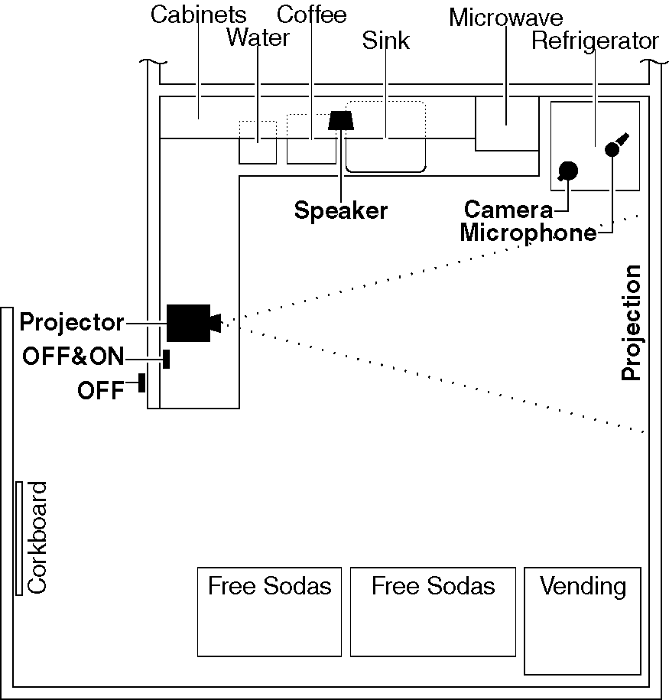
Figure 1. Plan view of a typical kitchen.
The design called for placing cameras at the center of the display, to maximize gaze direction awareness and impression of eye contact. However, difficulty in mounting and shielding it from glare led to temporarily positioning it on the refrigerator near the projection wall.
As was noted in the VideoWindow project [4], people often have semi-private conversations in public spaces. We did not find technologies to enable this at reasonable cost and ease of use, so we deployed a full duplex system that broadcast sound uniformly.

Increasing Interaction
We decided on an initial deployment of 3 kitchens, with a fourth quadrant devoted to attracting the attention of kitchen visitors. After considering alternatives we chose the CNN broadcast. Another potential benefit of this attractor is to extend the kitchen visit, increasing chance encounters.

Privacy Issues
Following the reaction to our planned recording of kitchen activity, we carefully alerted the organization to the research system prior to its arrival through an email broadcast and explanatory mockups displayed well in advance of deployment. The mockup is visible below the projected display in Figure 2. A public discussion list was created for issues related to the project.
Responses to our announcements made it clear that some people felt strongly that their kitchen activity, although it could be interrupted at any time by someone walking in, would be compromised by being observed.
It was apparent that we needed to allow people to opt out of participation easily. An OFF button positioned prominently outside the kitchen interrupted AV transmission; normal operation resumed after a fixed time elapsed. During this interval the display for the disabled kitchen showed drawn blinds and counted down the seconds to resumption. Inside the kitchen are large ON and OFF buttons, the former overriding the block and the latter enabling people in the kitchen to block (or re-block) the view.
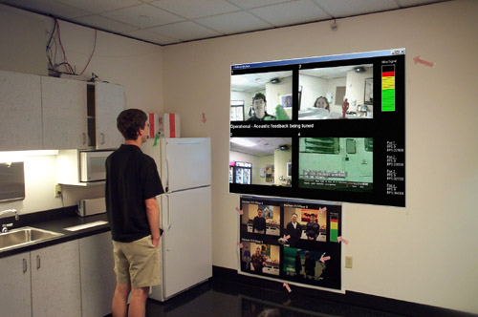
Figure 2. The projected display (retouched for clarity).
Someone approaching from outside might not be aware of a conversation in progress, so heat and motion sensors detect presence in the room and disable the outside OFF button when someone is in the kitchen. A person approaching will presumably not wish to interrupt a colleague’s conversation inside. The sensors could support other features if they appear necessary: a notification sound to other sites when someone enters; after an OFF button is pressed, privacy can be extended until the kitchen is unoccupied.
Although audio and video are not recorded, we anonymously record kitchen occupation using the sensors. We also log use of the OFF and ON buttons.

INITIAL ADJUSTMENTS
In the first hours and days of use we received feedback that led to some quick changes.
The OFF duration of 20 seconds was deemed inadequate and extended to 180 seconds.
We made fine control of audio a priority to enable the automatic lowering of CNN audio when people spoke, but some felt the presence of CNN audio inhibited conversation initiation and complained of ‘noise pollution’ in general. We switched to CNN’s closed captioning text alternative.

TECHNICAL SYSTEM DESCRIPTION
Each kitchen is required to:
- Capture and stream video and audio to the other two kitchens,
- Render video from all three kitchens and play audio from the two other kitchens, as well as video (and potentially audio) for the CNN channel,
- Provide privacy features, and
- Support system administration, notably daily activation and deactivation of projectors and speakers.
A primary goal is to run reliably on readily available hardware. Considering the video size and processing requirements we based each kitchen on a single networked Pentium III 550Mhz workstation running Windows 2000.
Our goal of leveraging existing audio/video streaming technologies succumbed to the exacting requirements of our real-time system. We needed point-point AV latency of under one half second. Tight processor and network usage, frame rate and compression algorithm control were also required. Of the technologies considered, Microsoft Windows Media is aimed towards one-way Internet streaming and introduces 10 seconds of buffering latency between the capture device and player. Microsoft NetMeeting video conferencing has sub-second latency but is a non-multicast peer to peer solution lacking interfaces for tight control of frame rate and compression. TAPI streaming technology, despite sub-second latency and multicast capabilities, doesn’t provide the other tight controls we required.
Figure 3. Hardware infrastructure.

Video
We chose forward video projection to present an acceptably large image at a reasonable cost. Considering CPU processing and network bandwidth requirements to compress, decompress, and stream video using existing compression algorithms at an acceptable frame rate, we chose CIF frame size (352 x 288 pixels). Given the proposed interface’s grid layout of video frames within the display we chose 800 x 600 projector resolution, producing acceptably viewable video frames. For the video capture device we selected the Winnov Videum.
The capture frame rate, compression algorithm, and bandwidth control algorithm were determined by monitoring processor and network usage during full laboratory runs of the system, consisting of:
- Audio capture and compression
- Video capture and compression
- Local captured video rendering
- Audio decompression and playback (3 streams)
- Video decompression and rendering (3 streams)
10 frames per second consumed only 41% of the 550Mhz processor, each of the 4 streams consuming 300kbps of network bandwidth. We kept the frame rate to 10 per second as a safety margin given other network traffic on the LAN.

Audio
Figure 4. Software infrastructure.
Audio was, and still is, the greatest challenge. Given the goal of casual and natural interaction, an open speaker/open microphone full duplex system was the only solution. The signal that is played by the speakers is also recorded by the microphone, hence a speaker hears an echo. Typical videoconferencing applications steer around this by a combination of half duplex operation, headphones, low speaker volume, and reduced microphone sensitivity. Introducing multiple end points, full duplex operation, reasonably loud speaker volumes, and sensitive microphones turns the echo effect into unrecoverable acoustic feedback.
We tried to address echo cancellation with an inexpensive integrated speaker and microphone product, but we found that the device often operated in half duplex mode in response to a strong signal. Also the device produced insufficient volume in our environment. An alternative hardware solution with a full DSP processor was prohibitively expensive. The final solution was a software- based echo canceling algorithm, which works well but not flawlessly, being still under development. The unusual composition of frequencies produced by the kitchen appliances created problems beyond the scope of the canceller. The refrigerators and vending machines produced sinusoidal tones that were hard for the echo canceller to cross-correlate; hence, it had difficulty removing them, resulting in feedback. This was solved by developing a frequency analyzer and dynamic filter that identified these tones and removed them from captured audio samples.
The acoustical characteristics of available microphones forced tradeoffs. Array microphones offer excellent noise removal and speech response, but their integrated automatic gain control interferes with the software echo canceller. Regular single condenser microphones have varying frequency response characteristics, each accentuating undesirable effects.

Privacy Controls and Presence Monitors
Large paddle buttons from Don Johnston Inc. were connected to the computer using their Switch Interface product, cleanly mapping button events to easily-intercepted keyboard events. Radio Shack security motion sensors were interfaced to the button interfacing hardware, configured in the normally-open state so that a motion sensor trigger would result in simulating a keyboard event.
Software responds to the OFF buttons by controlling the sample data that is sent in the AV stream to the other kitchens. A static image of closed window blinds is streamed and the audio capture and playback samples are zeroed out, producing silence. It was necessary to stream the blank data to maintain synchronization and consistent audio mixing within the other kitchens.

System Administration
Considering the expense of video projector light bulbs it was decided that the projector was to run only during work hours, so the projectors and speakers in three locations needed to be turned on and off each day. Custom electronics were developed to safely interface the workstation’s parallel port to control a relay, so the workstations can perform this task autonomously. An opto-isolator chip drives a switching transistor that applies power to a 10A 240V relay. A diode prevents the relay release inductance voltage from being introduced into the circuit. An integrated regulated power supply was developed to drive the circuit and the motion sensor.

Cost
550Mhz Pentium III workstation, Ethernet, high performance video card, 16-bit full duplex audio, camera and microphone). | ~$1200
Video Projector and mount | ~$5000
Motion sensor, Buttons, keyboard interface | $300
Cabling, connectors, custom power control | ~$250
Total | ~$6750

Table 1. System cost per installation.
Table 1 details the cost, assuming availability of a high speed local area network.

PATTERNS OF USE
We have three sources of information on the reactions to and use of the system. Observations, discussions, and email provided informal feedback. The logs of sensor data and button use provided detailed quantitative records of occupancy and privacy activity. And after about four weeks of use, an invitation to take a 25-question web survey was sent to the 220 people on the three floors involved, worded carefully to encourage participation regardless of use or opinion. Ninety one (41%) of the people filled out the survey, with many contributing to the three open-ended questions.

Decorations and Spoofs
The most unexpected consequences were creative responses to the system and the controversy that it generated. Soon after deployment, those entering a kitchen saw a green lizard staring at them from one of the kitchens. In fact, someone had moved back the camera slightly and taped a lizard to the refrigerator in front of it. Looking closely at Figure 2 you will see the lizard and its image in the upper left pane. The lizard does not entirely block the view of people and was treated as a humorous system extension. A silhouette cut-out appeared in front of a different camera.
Although minor, these decorations were noticed and remarked upon by many people. They helped to humanize the system. Although they were not placed there by our team, we were grateful to the inventors. The principal drawback was that moving back the camera brought the white refrigerator top into the camera field, which increased glare in the transmitted image.
Not long after deployment, a meticulously executed “Virtual Men’s Room” spoof appeared outside and inside a nearby men’s room. Organized around the notion that this was another place where people spent time in isolation that might afford opportunities for informal interaction through the placement of cameras and microphones, this funny, PG-rated parody mocked our explanatory notices and the potentially intrusive aspects of the project.

Sabotage and Controversy
The mildest forms of sabotage were written images and messages (for example, a rough pen drawing of two people talking in the kitchen) placed in front of the camera that entirely blocked the view of the room. More extreme, several times the system in one kitchen was disconnected. This occurred despite our efforts at privacy control.
Privacy was the topic of considerable discussion and email traffic. A person with disabilities described avoiding using the kitchen when others were present; others said that they did not mind if those who worked nearby saw them live but were uneasy about relative strangers in another building. The lack of reciprocity was noted: someone can stand outside the camera range in another kitchen and see.
Some people did not trust that video was not being recorded. Some incorrectly believed that the OFF button would block the camera but not the sound. Others worried that they would forget or that visitors accompanying them would not realize they were being viewed.
Such feelings had effects. At least once, a person entered a kitchen where a colleague was conversing with someone in another kitchen. The second arrival walked over and pressed the OFF button, terminating the conversation.

Patterns of Occupation
The sensor data for two workweeks (August 7-11 and 14-18, 2000) were classified into “occupations” – times that the motion detector sensed continuous activity. An occupation is a series of motion detections separated by less than 30 seconds. It may represent one or more individual visits, as the detector cannot differentiate between individuals or the number of individuals present. Each occupation was recorded with kitchen number, start time and duration, and the interval (if any) that the system was disabled by the button. 5611 occupations were recorded.
The median occupation duration was 23 seconds. The distribution was highly skewed, with the mode being 6 seconds, the time needed to grab a drink. Overall there was an average of 7.8 occupations per hour in each kitchen. The number varied by hour of the day, as would be expected (see Figure 5).
Figure 5. Average number of occupations and opportunities for interaction per kitchen for each hour of each day.

Patterns of Opportunities
Times when pairs of kitchens were occupied represent “opportunities” for interaction. An opportunity was recorded with start time, duration, and the kitchens involved. Opportunities are pair-wise – all three kitchens being occupied represents three distinct opportunities. 1577 opportunities were recorded.
The median opportunity duration is 13 seconds. The distribution is highly skewed, with the mode being 3 seconds. Overall, one or more opportunities for communication occurred during 41% of the occupations. The number of opportunities varied with the square of the number of occupations (see Figure 5)
Opportunities were indeed recognized by visitors to the kitchens: 81% responded to the question, “How often have you noticed one or more people in the other kitchens?” with a response “occasionally” or “often” (see Figure 6). However opportunities rarely turn into communication. Only 21% had those same responses to “How often have you waved or gestured at someone in another kitchen?” Fewer still (4%) had those same responses to “How often have you spoken to someone in another kitchen?”
Figure 6. Responses to survey questions about interaction with people in other kitchens.

Figure 7. Survey respondents classified by privacy score.

Privacy
Most people felt that the privacy solution as implemented addressed their privacy concerns (71% agree or strongly agree with the statement “The OFF switch effectively addresses your privacy concerns,” or indicated that privacy for them is not a concern). The OFF button was used infrequently: for 90% of the occupations, the system was enabled for the entire occupation.
Privacy remained a concern for a minority. Assigning a “privacy concern” point to any of these survey responses:
- The 7% responding 100% to “For what percent of kitchen visits have your turned off the camera using the red OFF button as you entered?” (This matches the OFF button sensor data.)
- The 15% who rated “How serious do you think privacy issues are for VK?” as “very important.”
- The 7% who strongly disagreed and 7% who disagreed that “The OFF switch effectively addresses your privacy concerns.”
- The 9% saying “VK affects your privacy” “a lot.”
With this scoring, 78% or survey respondents had a score of zero, indicating little remaining concern for privacy (see Figure 7). The remaining 22% had a score of one or more.

Audio and Video Quality
People perceived the audio quality to be too low but considered the video quality adequate. To the question, “On your most recent visit, the quality of the video was,” 62% responded “acceptable” or “very good.” To a similar question for audio, only 16% had those replies.
While audio quality was perceived inadequate, it is considered a minor problem in the larger picture of usability. When asked “Would improved audio and video quality change your experience?” 30% replied “not at all,” 42% responded “somewhat,” and 21% replied “a lot.”
Figure 8. Responses to survey questions about audio and video quality.

We pushed the limit of today’s inexpensive audio hardware, but audio quality was the most common complaint. The audio was being worked on during system use, so negative first impressions could be a factor, but in fact microphones are not as capable as the ear, and to cleanly filter out noise requires better technology and algorithms than are affordable now.
Video presents similar challenges. Room lighting and glare are problems, in our case amplified by the creative repositioning of cameras. Although the latter seems a valuable feature to preserve, a glare-reducing surface around the camera could help. Another design change suggested by survey respondents (and in our original plan) is to position the camera within or closer to the projection area to increase the perception of eye contact.

The Fourth Pane
While most visitors reported glancing at the other kitchens, a relatively small number glanced at the CNN feed. To the question, “How often do you glance to see if other people are visible in the other kitchens?” 73% answered “occasionally” or “often” (see Figure 9). To the same question regarding CNN, only 35% had those responses.
Figure 9. Responses to survey questions about glances at the display.

Closed captioning is preferred strongly over playing the CNN audio track. When asked “We have tried CNN with sound and with closed captioning (scrolling subtitles). Your preference is:” 43% responded “closed captioning over sound” and 19% preferred “sound over closed captioning.” It is unclear whether the merits of closed captioning or the faults of audio in a public space explain this preference.
Was CNN the best choice for the fourth-frame lure? Many alternatives were suggested. Some involve interactive games, such as an ongoing chess game to which visitors could contribute a move. Other displays are possible, such as a biographical or work sketch of a member of the organization selected randomly (from those willing to be included), traffic web-cams, news headlines, etc.

A Need for Informal Interaction
The survey results indicate that there is an opportunity for some kind of informal interaction. Survey respondents showed strong support for the problem that we’re trying to solve: fostering informal interaction amongst researchers. To the question, “I think the level of informal interaction in Microsoft is,” 78% responded “much lower than it should be” or “somewhat lower than it should be.” Not a single respondent indicated that there was too much informal interaction.
The survey showed support for some level of technological mediation of informal communication. To the question “What role do you think technology could have in facilitating informal interaction if implemented appropriately?” 53% responded “moderate” or “strong,” 34% responded “weak,” and 5% responded “none.”
As reported above, 73% of respondents reported glancing at the display at least some of the time.
There was substantial support for continuing the experiment. When asked “The VK experiment should be” 46% responded “continued” or “expanded,” and 26% answered “discontinued.” To gauge which of the “discontinued” responses were due to privacy concerns and which were votes of no confidence, we segmented the responses by the privacy score described above (see Figure 7). The respondents who scored one or more were considered separately from those who scored zero. Of the privacy-concerned group (n=35), 60% responded “discontinued” and 10% responded “continued” or “expanded” (see Figure 10). Of the group expressing no privacy concerns (n=56), 17% favored project termination and 56% favored continuation or expansion.
Figure 10. Responses to survey question about whether the project should be continued, segmented by privacy score.

Thus we believe that we are addressing a real problem, and that there is an acceptable level of support for this type of solution, particularly if we can address privacy concerns. But not everyone can be satisfied: A few survey respondents recommended removing the OFF buttons!
On the other hand, respondents feel that the potential for a technological solution to foster informal communication is inherently limited. When asked “What role do you think technology could have in facilitating informal interaction if implemented appropriately?” 53% responded “moderate role” or “strong role,” 34% responded “weak role,” and 5% indicated “no role.” When asked, “How do you assess the potential for the Virtual Kitchen project to facilitate informal interaction?” 22% responded “moderate” or “substantial.” The non-technical solutions enjoy more support: To a similar question regarding the weekly mid-afternoon snack break, 70% had those same responses. To a third question regarding the monthly social event, 79% had those same responses.

DISCUSSION

The Choice of ‘Public Spaces’
As noted earlier, kitchens were not the only possibility. At this point it seems a reasonable choice, but it is possible that it led to some of the sensitivity. Some people may be uneasy about putting their consumption of junk food or caffeine on public display, others about the number of trips they could be detected making.
Potentially, we have four more kitchens upon which to draw, which would substantially increase opportunities for interaction. It might be oppressive to have seven displays, and showing only those with activity could lead to difficulty maintaining reciprocity. The display first active could perhaps be shown larger than subsequent ones.

Privacy and Controversy
Why didn’t the literature on video support for informal interaction prepare us for the controversy over privacy and public space? It may be due in part to changing times – technological encroachments on personal information and space are more widely discussed today. With widespread security cameras, ‘reality TV,’ webcams that enable parents to monitor children in daycare, we as a society are sorting out our attitudes to video technologies. Particular individuals or organizational cultures may play a role.
In retrospect, however, other factors are compelling. Most previous experiments involved smaller groups of more tightly-knit researchers. Some papers argued that one’s colleagues should feel fine about allowing unannounced one-way video visits to their offices, indicative of a level of trust that is usually confined to small groups.
Consider the Bellcore VideoWindow experiment. Fifty of the participants volunteered to move their mailboxes to the common areas. Others who wandered in were rewarded by free coffee that was otherwise unavailable – being viewed was a price they agreed to pay. The free drinks in our kitchens were available before, so there was no quid pro quo for employees who did not value the possibility of interacting through the system.
One conclusion is to introduce a system especially carefully when it brings no obvious new benefit to everyone. Our use of a distribution list for airing grievances seemed useful, although it led us to believe there were more dissatisfied people than the survey and sensor data suggest.

CONCLUSION
It is too early to tell whether this technology is significantly enhancing informal interaction in our organization. It may never be possible to measure it with confidence. The experiment has generated discussion and raised technical and social issues. We partially succeeded in a technical implementation based on relatively inexpensive hardware. The cost of the hardware will fall, its quality will rise, and similar efforts will be easier. Attitudes are likely to change with experience and generational change – children who grow up surrounded by cameras and camcorders may respond differently than previous generations.
Lessons from this ongoing work, not predictable from the prior literature, could benefit those who conduct future experiments.

ACKNOWLEDGMENTS
We thank Jay Stokes, Rico Malvar, MSR Technical Support, Yong Rui, Li-Wei He, and Dan Bersak.

REFERENCES
- Dourish, P., Adler, A., Bellotti, V. and Henderson, A., 1996. Your place or mine? Learning from long-term use of video communication. Computer-Supported Cooperative Work, 5, 1, 33-62.
- Dourish, P. and Bly, S., 1992. Portholes: Supporting awareness in a distributed work group. Proc. CHI’92, 541-547.
- Finn, K.E., Sellen, A.J., and Wilbur, S.B., 1997. Video-mediated communication. Erlbaum.
- Fish, R.S., Kraut, R.E. and Chalfonte, B.L.., 1990. The VideoWindow System in Informal Communications. Proc. CSCW’90, 1-11.
- Fish, R.S., Kraut, R.E., Root, R.W. and Rice, R.E., 1992. Evaluating video as a technology for informal communication. Proc. CHI’92, 37-48.
- Gaver, W., Moran, T., MacLean, A., Lövstrand, L., Dourish, P., Carter, K. and Buxton, W., 1992. Realizing a video environment: EuroPARC’s RAVE system. Proc. CHI’92, 27-35.
- Goodman, G.O. and Abel, M.J., 1986. Collaboration research in SCL. Proc. CSCW’86, 246-251.
- Kraut, R.E., Egido, C. and Galegher, J., 1990. Patterns of contact and communication in scientific research collaboration. In J. Galegher, R.E. Kraut, C. Egido (Eds.), Intellectual teamwork: Social and technological foundations of cooperative work (pp. 149-171). Erlbaum.
- Olson, M.H. and Bly, S.A., 1991. The Portland Experience: A report on a distributed research group. In S. Greenberg (Ed.), Computer supported cooperative work and groupware (pp. 81-98). Academic Press.
- Root, R.W., 1988. Design of a multi-media vehicle for social browsing. Proc. CSCW’88, 25-38.
- Tang, J.C. and Rua, M., 1994. Montage: Providing teleproximity for distributed groups. Proc. CHI’94, 37-43.

