KidTalk: Online Therapy for Asperger’s Syndrome

Lili Cheng

January 28, 2002

Technical Report
MSR-TR-2002-08

Microsoft Research
Microsoft Corporation
One Microsoft Way
Redmond, WA 98052

KidTalk: Online Therapy for Asperger’s Syndrome

Lili Cheng, Greg Kimberly
Microsoft Research
Felice Orlich, PhD
University of Washington
Contact: lilich@microsoft.com

ABSTRACT
We have created KidTalk, an online environment used to treat children with Asperger’s Syndrome/High Functioning Autism. This paper describes our design process, the system, deployment, and assessment. Children with Asperger’s Syndrome often demonstrate poor communication and social skills despite their tendency to be verbally precocious. Consequently, these children often struggle with loneliness, anxiety and depression. Current small group face-to-face therapy focuses on teaching social communication skills, but clinicians have difficulty delivering their services to an increasing number of patients. KidTalk is a software environment that runs scripts for interaction and rewards progress and socially appropriate behavior, and provides therapists with group therapy and feedback tools. Going forward, we hope KidTalk can provide more access to treatment for Asperger’s Syndrome.

Keywords
Asperger’s Syndrome, social skills, social scripting, turn taking, autism, treatment, text chat, online therapy

INTRODUCTION
We have created KidTalk, an online environment used in the treatment of children with Asperger’s syndrome. This paper describes our design process, the system, and our deployment/assessment plans. Children with Asperger’s Syndrome often demonstrate poor communication skills despite their tendency to be verbally precocious. Their focus is often placed on objects more than people, leading to misinterpretation of salient interpersonal cues, both in conversation and in nonverbal communication. Consequently, these children are frequently socially isolated and often struggle with loneliness, anxiety and depression. Current small group face-to-face therapy focuses on teaching social communication skills, but clinicians have difficulty delivering their services to an increasing number of patients, especially those in outlying geographic areas. [6,9] The Center for Disease Control estimates that 1 in 500 individuals suffer with an Autism Spectrum Disorder. This is a higher prevalence rate than for childhood cancer and diabetes [2]. In the Seattle area alone, children often wait one year for service provision. KidTalk provides children and their families with a software environment that runs interaction scripts and rewards progress and helps teach children communication skills. KidTalk also provides therapists with feedback and assessment tools. Going forward, we hope KidTalk can provide more access to treatment for Asperger’s Syndrome.

BACKGROUND
Among the disabilities treated at the University of Washington Autism Center [1] is Asperger’s Syndrome, a form of Autism. Neuropsychological characteristics of children with Asperger’s include poor social cognition, poor pragmatics, disturbances in attention, concrete vs. abstract thinking, obsessive focus on areas of interest, and strong rote memory and memory for events. Socially, these children have difficulty shifting topics and making transitions, have difficulty with social interaction (particularly group interaction), and often suffer from loneliness, anxiety and depression.
Current face-to-face intervention strategies include providing increased predictability, increasing structured interaction time, and directly teaching social communication and perspective taking skills. Therapists clarify social rules and contingencies, letting children better predict social outcomes. For example to improve non-verbal communication skills, therapists teach children to listen for tone of voice and attend to the eyes and facial expressions of another person. Therapists also teach children social scripting and structures for interaction. For example, when meeting someone new, take turns in the conversation by first introducing themselves, then waiting for the other person to respond, and finally asking the other person questions and listening to their response. These interaction scripts are currently taught through role play, videos, observation of other children, and practice at home When the children follow social rules, they are rewarded with tokens, pictures, and un-moderated conversation (for example, text chat).

Current Group Therapy Treatment
Today, in a typical group therapy session, 3-5 children of similar age/sex/stage of treatment meet together with the goal of improving their social skills. The age for group interventions varies widely as do the goals for intervention. Typically, group intervention begins at age 4 and extends through adolescence. Groups targeted for younger children frequently use a play based model. Those for older individuals use a combination of social scripting, role play and “free time” to facilitate group affiliation. As children with Asperger’s usually demonstrate strengths in reading and writing, verbal and visual media are typically used. In the Autism Center, all groups are accompanied by a parent support component. Meeting outside of the structured group sessions is also strongly supported.
During early phases of treatment, group meetings typically provide a high level of intervention and guidance. For example a therapist may literally stand behind each child, telling him/her what to say and do so for the duration of the meeting. Over time, the scaffolding is reduced or eliminated, and the children learn to generalize to novel situations. To reward progress and socially appropriate behavior, children are motivated with different types of rewards and feedback. For example, most of the children have strong, hyper-focused interests in things such as Pokeman, Harry Potter, weather and computer games Appropriate toys, stickers, etc. are given as incentives.
Some online tools are currently used as part of group interventions at the University of Washington Autism Center. For groups that have interacted face to face, and have passed the early phases of treatment, standard online community and chat tools such as Microsoft Network (MSN) Communities [7] are used during treatment. For example, the therapist/staff member may have everyone log on to a private chat room and lead a discussion on a particular topic. A reward for progress has been to give these children time to chat on topics of their own interest using text chat with others in the group. These children appear to enjoy working on the computer and enjoy using computer mediated communication (text chat).

All children currently undergoing group therapy at the Autism Center have previously been diagnosed with Asperger’s Syndrome in the Autism Center, or by other clinicians. Prior to entering the group, records are reviewed to assure that cognitive skills and level of previous interventions match. If needed, social-communication skills are formally assessed using the Autism Diagnostic Observation Schedule (ADOS). The ADOS is the gold standard instrument for face to face assessment of communication and social skills, both verbal and nonverbal. In addition, parents and teachers are asked to complete questionnaires to set target goals for each group. These questionnaires are again completed at the close of group and six months post completion to assess group effectiveness.

Related Work
Improving social skills is a primary intervention target for children with Asperger’s. Previous work indicates that structured environments offering clear social contingencies are best at facilitating skills development [5]. To date, the majority of interventions have utilized face-to-face interventions using social scripts and role play [10]. While the efficacy of these approaches is not well established, gains are most often seen when group therapy is integrated with the children’s day to day experiences [5]. On-line therapy environments may provide an accessible and unique opportunity for this generalization of skills.

While there is good evidence that computer-aided learning is well accepted by individuals with Autism Spectrum Disorders and of potential benefit to them, the use of technology remains relatively unexplored [8]. For example, previous work done by Mitchell and Rajendran in the Bubble Dialog program at the University of Nottingham [11], shows that computer-mediated role-taking may help to regulate interaction. Ongoing work is needed to more effectively assess the effectiveness of treatment using the Bubble Dialog program. Given the suggested benefits of an on-line environment and established acceptance of computer based media by individuals with Aspergers, we anticipate that on-line therapy can:
- Allow for a structured, more controllable reality [3,4]
- Offer a safe role-playing environment
- Reduce anxiety via indirect interactions and environment
- Offer a means for generalization of skills learned in face-to face interactions
- Facilitate affiliation with peers and others

LeadLine Project
KidTalk is based on the LeadLine project [3,4] which was developed to provide structure online text chat. In the real world much social interaction is guided by an implicit script [6]. In online text chat, conversation is unstructured and undirected. People join the conversation at different times, there are many simultaneous conversations, and often a large amount of conversation is focused on miscommunication. LeadLine, (see Figure 1) was developed by Microsoft as a response to unstructured online conversation. For example, when meeting friends for coffee, we first meet and catch up, we order coffee, and then we sit down and have more in-depth conversation. After about 30 minutes, if everyone is finished, we say goodbye.
Using LeadLine, an author can script the social interaction by providing roles and scenes using an easy, declarative script creation process. Scenes can be advanced by one or all of the participants, or by a pre-determined amount of time. We discovered that our participants found LeadLine more fun than regular text chat [4]. We also found that in business scenarios, users were able to better reach consensus when decision making using LeadLine than using text chat [3].
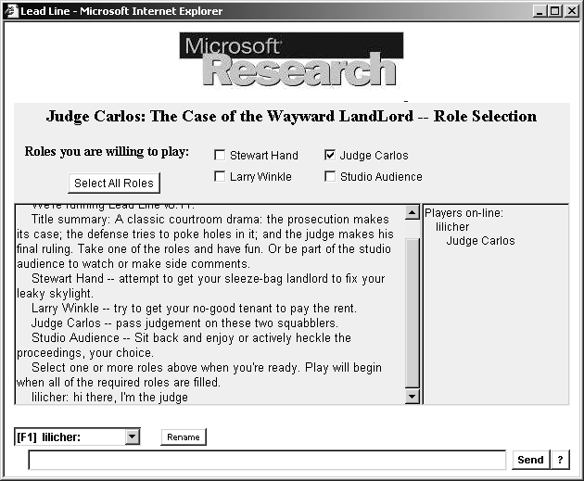
Figure 1: LeadLine Client User Interface

KIDTALK: PROJECT OVERVIEW AND GOALS
The KidTalk project and collaboration between Microsoft Research, Social Computing Group [13] and the University of Washington Autism Center began when Dr. Felice Orlich saw a demo of the LeadLine project (note: LeadLine is described later in this paper) created by the Social Computing Group in Microsoft Research. Dr. Orlich thought that this tool would be extremely effective for providing treatment for children with Asperger’s syndrome, because the tool could be used to replicate, complement and extend current treatment techniques.
In our partnership, the Autism Center hopes to improve access and quality of treatment, facilitate a sense of community and belonging for individuals, and provide cost effective mechanisms for assessment. The Autism Center will provide scripts, the treatment environment, and assessment. Microsoft hopes to develop tools and technologies that support communication-focused services, and learn how to foster productive, engaging social interaction. Microsoft will develop the software and tools, based on the LeadLine software. We are currently working together to design, develop, deploy and assess the effectiveness of online therapy using the KidTalk tool.
Our goal for the KidTalk project is to design client software, scripts, and feedback/assessment tools for children with Asperger’s undergoing group therapy at the Autism Center. Ultimately we hope the tools may be used for more general audiences.

Design Process and Methods
The collaboration has occurred over the past six months. During this time we have met many times, visited and observed work environments, worked on joint presentations of the project, got feedback from children and therapists using LeadLine, and created new prototypes and scripts. We plan to test the current design with children receiving group therapy in the Autism Center over the next few months.
Once we better understand how this prototype is used at the Autism Center by children, we will conduct formal controlled studies. We anticipate three phases of study, proceeding from a) “within” KidTalk to b) unmoderated on-line environments to c) real time/face-to-face environments. The early phase of research will also explore the usability of the KidTalk environment for individuals with social communication deficits and potential implications for future development of computer aided learning tools for these individuals.

The Users

The initial KidTalk users are a small subset of children undergoing group therapy at the Autism Center and staff from the center, selected by therapists at the Autism Center. We currently have identified 2-5 groups of 4 children, plus several therapists and aides as participants. Selection criteria are influenced by the nature of the group, length and stage of group therapy, and age of the children. In this phase, the KidTalk project is being used as part of the children’s current group therapy, and is reliant on direction and feedback from therapists also present in the online therapy session.

In the beginning of 2002, we plan to modify our designs based on feedback, and we will design and deploy a controlled research study to an extended group of users at the Autism Center.

Early Observations and Feedback
Before beginning the design of a software solution, the Autism Center team, children undergoing group therapy, and the Microsoft team gathered information and met to discuss many different possible collaboration scenarios.
We reviewed and shared past research, demo’ed existing software and created several overview presentations together. During the early phase two events were extremely influential on the resulting KidTalk project design; an observation of treatment sessions and feedback on the LeadLine project from children in group therapy. Shortly after these two events, we decided to begin the KidTalk project. This project included a revised LeadLine user interface (for this particular audience), a new set of scripts, and integrated feedback and assessment mechanisms.

Observing a treatment sessions
The therapists at the Autism Center invited the Microsoft researchers to observe a 1:1 treatment session between a child and a therapist. On the Microsoft side, we were unfamiliar with the Autism Center and children with Asperger’s. Seeing an actual therapy session gave us a much better sense of the attention span and the type of scenarios that might be appropriate for this audience. Because we could easily imagine how some of the scripted interaction could be supported in a structured text chat, this also reinforced our belief that this would be an appropriate treatment mechanism.

LeadLine Feedback from Children with Asperger’s
To evaluate the children’s interest in using pre-scripted text chat in an online environment, we had a group of children currently in group therapy at the Autism Center use one of the pre-written LeadLine scripts.
The “At the Restaurant” LeadLine script was written for a general Internet audience, not children, and not people with Asperger’s. The script is a parody of an American couple dining in an exclusive French restaurant. Users can select one of four roles: a French waiter, an American couple on a date, and an audience member. In the story, the couple goes through a variety of humorous and uncomfortable dining experiences and each user is given particular instructions depending on the role. For example, the French waiter is told to be rude and to make the couple feel uncomfortable.
After the children used the script they gave the therapist feedback on both the LeadLine software and the “At the Restaurant” script. First, it was clear that the script needed to be more appropriate for the group. The therapists and children both thought that scenarios such as “Going to a party” or “Meeting a new friend” were more relevant, and they found the general entertainment script disorienting.
Overall, however, the kids and therapists were excited by the use of LeadLine, as they felt this type of tool would complement existing face to face group therapy. The users enjoyed the structured LeadLine conversation, but found the text only user interface “boring” in comparison to tools they currently use such as MSN Chat and MSN Communities. The MSN software provides small graphical emoticons in the text chat and customizable text fonts and style. They suggested incorporating more types of expressive graphics text.
As we observed with general LeadLine users, the children with Asperger’s tended to get disoriented by the scene transitions. The children were confused when the story began, and when the scenes transitioned. They were also unsure “where they were” in the story and how many scenes were left.
The therapists had suggestions regarding the feedback, scripts, and assessment. They wanted to be able to give direct feedback to each child. They wanted to be able to customize instructions and scripts for particular individuals and for children with Asperger’s. They also wanted more explicit directions/goals for particular scenes, and better evaluation, data collection, and assessment mechanisms.
We brainstormed on potential features and user interfaces and we discussed many ideas including how we might be able to reduce scaffolding/instructions over time, add incentive/reward mechanisms, customize user profiles, automate feedback based on participation in the text chat conversation, and so forth.

PRELIMINARY DESIGN PHASE

User Interface Design
At Microsoft, we began to prototype a new user interface after getting feedback from the children and therapists. We first sketched the designs and then reviewed them with the therapists.
To make the user experience more interesting we added a graphical representation of the group. We presented several alternative sketched designs to the team at the Autism Center. For example, in some designs the participants were graphically represented by full body or by face only. We experimented with different representations of the conversation (text bubbles, linear text history) and different user interfaces for integrating the graphics and text conversation. We decided to focus on the faces of the users (not full body), with particular emphasis on the expression and eye gaze. Therapists thought this would reinforce social skills training. We decided to make the conversation as easy to follow as possible, and decided not to pursue the chat bubbles or user interfaces that focused on the graphical representation of the group over the focus on the conversation. Figure 2 shows some of the early designs that we decided not to pursue after getting feedback from the therapists, and Figure 3 shows the design concept that most closely resembled our current KidTalk user interface design.
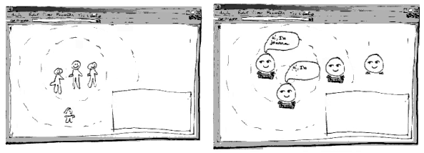
Figure 2: Preliminary Designs

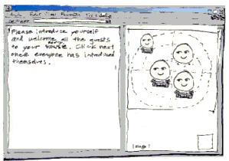
Figure 3: Preliminary Design, Basis of Current Design

In the chosen preliminary design, as with the current design, the text chat history and text input appear on the left side of the screen. The group representation is in the upper right, and the individual feedback area is directly below the graphical view. Our intent is to create a lightweight, engaging, fun, responsive and effective feedback tool.
In the graphical representation of the group, the position, size, and expression of individuals reflect activity level. If users are too active or too aggressive they move to the center of the circle. If users do not participate enough or are too passive they move to the outside of the circle. The face size (larger face is more active), and its expression (asleep, big mouth) also indicate activity and social interaction.
Through conversation, people often indicate who they are talking to by beginning the chat statement with the user name. Children with Asperger’s are encouraged to look at the person they are talking to. We reinforce this behavior by having the eyes of an individual’s graphic “look at” the appropriate participant.
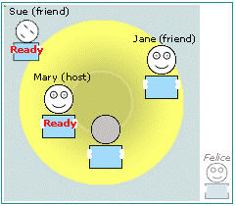
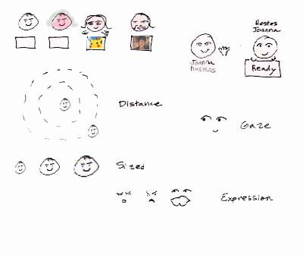
The children can customize their appearance of their user profile (see Figure 4). The degree of customization corresponds to the experience level and scores of the individual. In addition, user status (e.g. ready to go to next scene, finished with my goals) is displayed in the group view. Figure 4 shows some of our early ideas of how to represent these ideas in the individual and group representation. Once we decided on a design direction, the Microsoft team began developing a working prototype

Figure 4: Early Sketches of Emotion and Status Indicators

Scripts, and Assessment
While mocking up the user interface design at Microsoft, therapists at the Autism Center began drafting scripts for interaction, and designing data collection and assessment measures. After meeting and discussing several script ideas, the therapists decided on a “Birthday Party” scenario. In the Birthday Party scripts, guests arrive, introduce themselves, open presents and respond to gifts, and make arrangements to meet again.

A Test Run: KidTalk Prototype and Script
While working on the in-progress KidTalk prototype and with a very rough Birthday party script, we decided in the middle of an informal meeting to try out the new design. Everyone at the meeting logged on to the KidTalk website and selected a role, and we “played” the Birthday Party script together. Before investing a large amount of time creating polished scripts and the user interface, the test run helped us better understand the design problem, and also was a fun role-playing experience. The test run helped the therapists better understand how to write scripts (timing of the scenes within the script, role descriptions) and influenced the client user interface design, particularly the design of the scene transitions and feedback tools.

THE WORKING PROTOTYPE
From our early mockups and test run, we found that the KidTalk user interface and scripts needed to be extremely clear and simple. The children also need to get timely, concrete feedback. Our KidTalk prototype reflects this feedback.
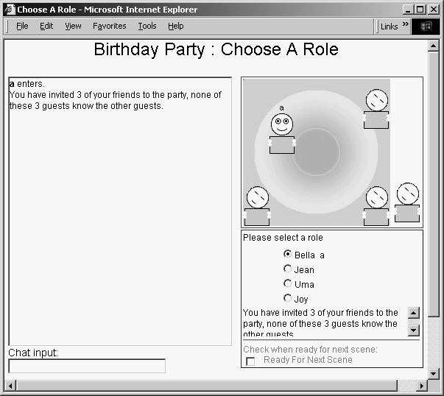
Figure 5: Working Prototype, Client User Interface

Selected therapy groups at the center will begin a KidTalk session by navigating to the KidTalk web page on their personal computer. Each individual will log in and enter the KidTalk session in the Birthday Party script. This page will contain a chat control and social status feedback display (see Figure 5), similar in design to the early sketched mockups.
In the first scene, the children get an overview of the Birthday Party script and roles. They are instructed to select a role via the personal information panel directly below the graphics area. The children can also chat to one another while waiting for others to enter and select roles. Once the children chose a role they signal that they are ready to start the story by clicking on the ready check box. A status display [see Figure 5] shows which children are ready to advance to the next scene and which are still not ready to move forward.
When everyone has selected a role and is ready to continue, or if the therapist controls and advance the scene, the story timeline is briefly displayed (see Figure 6), and then the role-playing begins. In the Birthday Party script, first the guest are greeted, they share a story and have cake, they exchange gifts, and finally they say goodbye. After the story is finished, a final scene transition is displayed with the individual’s feedback from the therapist and interaction summary. The script ends with a discussion/feedback scene. During the final scene other incentives such as images may be displayed in the graphics window.

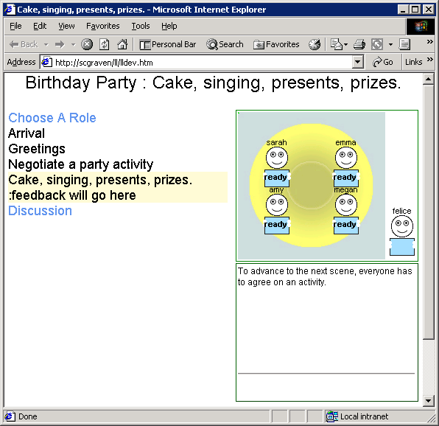
Figure 6: Transition Screen

During the entire session, the therapist appears in the group view, outside of the interaction space. Children can interact with the therapist, but in general the therapist does not participate in the role playing (but may give an individual feedback/guidance). The therapist plays an active role in the role selection scene and the discussion scene. The level of the therapist’s interaction is not determined by any particular limitation in the software, but rather guided by interaction techniques adopted from face-to-face interaction. We expect the software will be modified as we learn from the user studies.

User Profiles
Each user has a personal profile To view the user profile, a user can click on a person in the graphic window to bring up the person’s profile (see Figure 7).

Figure 7: Personal profile

A child can add pictures of interest to their personal profile. When the child does well, these images will be displayed in the user representation. The better a child does at achieving goals of social performance, the further they are allowed to customize their profile by adding pictures and text. We will continue to study the usage of the profile during our next phase of testing and will incorporate the feedback we receive into the final design of the profile. As we continue getting feedback from therapists and children, we expect the personal profile and access privileges to evolve.

Social Performance Feedback and Assessment

We are currently in the preliminary design phase of the social performance feedback and assessment tools. Before designing complex assessment mechanisms, we feel we need to deploy and watch how therapists and children use KidTalk to better understand how software may facilitate, extend, or automate feedback and assessment.

At this phase of design, we have a few simple mechanisms that will facilitate feedback and assessment. As mentioned earlier, the child’s position in the graphic window reflects his or her level of participation in the conversation. We automate this process based on the children’s interaction with others. For example, if the child does not participate at all, we will have them move out toward the edge, their avatar may fall asleep, and their avatar may get smaller.

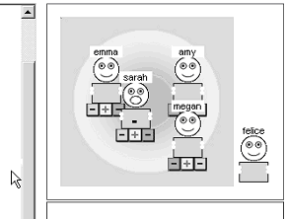
Figure 8: Therapist Client User Interface, Position Tool

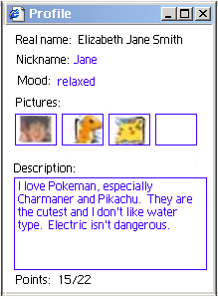
We are aware of limitations of automated feedback, so we provide the therapist additional feedback tools and a custom user interface with special commands to control scene advance. These tools let the therapist override and control scene advance as needed and also let the therapist override and control placement of the child’s graphic in the group view (see Figure 8).
We also provide real time feedback to the children through the therapists text chat, and we collect data across sessions to be able to provide individual and group interaction summaries.
Additional feedback/assessment ideas we are discussing include: a peer rating system (how one thinks others in the group performed), a therapist ratings/point system, and various data collection and analysis mechanisms.
By observing and analyzing the group interactions and feedback from the therapist, we will be able to better understand how we can ease/automate the assessment mechanism.

KIDTALK DEVELOPMENT

A primary goal of the KidTalk project, like the LeadLine project, is to be able to easily deploy the software over the Internet, and to provide access and services to a wide range of people. This means the software must be easy to install for end users, and it must be easy for therapists to create custom scripts and modify the feedback channels. Although our initial deployments and studies will only be used by small, secure groups, this is a limitation of the study, not of the software and technology.
The KidTalk software can runs on any standard Internet-connected Windows PC equipped with Internet Explorer. Like most web pages, the KidTalk web page loads quickly. Accessing the software does not require extensive downloads, rebooting a machine, or custom setup or hardware.

The Scripts
The scripts that guide interaction are designed to be easy to create. Using KidTalk, non-programmers can create a variety of scripts by cutting and pasting text into simple text files, and uploading the scripts into the system.
KidTalk scripts are declarative descriptions of how a group of roles move through a series of scenes. The declarative nature of KidTalk scripts allows nonprogrammers to easily create them. Each scene consists of a set of goals that each role is to accomplish and each scene contains a) background information about the scene for each role, b) the goal each role should strive to obtain, and c) the criteria for the scene to be finished. Scenes can either end when some specified subset of the roles signal that they are ready for the next scene or when a time limit has expired.

The Client
The KidTalk client is constructed of Dynamic HTML (DHTML) running on top of the peer-to-peer toolkit described in the next section. Delivering the client on this toolkit results in an application that is:
- Easily and quickly modified by people with web development skills
- Compact in size so it can be accessed via modem
- Responsive on current hardware and over low-bandwidth connections

KidTalk Architecture
KidTalk is built on top of software we previously developed for constructing distributed peer-to-peer applications out of DHTML web pages. The web developer builds the page as she would normally, then chooses Document Object Model (DOM) objects to declare as replicated. This declaration has the effect of making events that happen on one page take effect on all the pages across the session. For instance, the icon representing one of the children exists in a replicated form on all the pages in the current KidTalk session. The page used by the therapist contains additional local control objects that allow the icon to be moved. When the icon is moved by the controls on the therapist’s page, the toolkit takes care of assuring that the icon's position changes on all the pages.

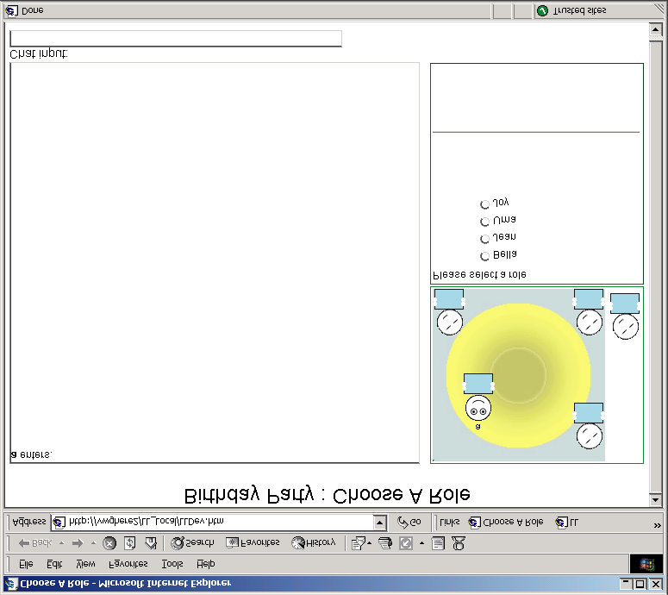Figure 9: Diagram of KidTalk Architecture
Clients: Peer to-peer communication

Back End:
Directory Services
Authentication
Logging
Profiles
This "program locally, effect globally" (replicated objects) approach to creating distributed applications results in much simpler implementations for a wide class of synchronous applications.

The Back End
While most communication between the clients is peer-to-peer, there are some services that must be centralized. KidTalk requires three central services.
First, the back end provides a basic directory service that allows clients to discover and connect to the other clients in a session. Second, we want to provide a secure environment for interaction, so we provide an authentication service. Finally, we need to store records of session activity so researchers can track and guide the progress of the children. The KidTalk logging service stores the activity as structured SQL database records.
These services are implemented as ASP applications running on top of IIS and SQL Server. The toolkit allows the clients to access all of these services in a simple and effective manner.

SUMMARY AND NEXT STEPS
In summary, we have gone through an iterative design process, to design and build a prototype to provide group therapy to children with Aspergers Syndrome. By quickly testing, deploying, and re-designing we hope to improve and increase accessibility to treatment. It is also our hope that efficient strategies for assessment of social-communication skills will emerge through the use and deployment of KidTalk.

Our immediate next steps are to continue our iterative design process by deploying the software to several groups of children currently receiving group therapy at the Autism Center. These sessions will be closely moderated by therapists/staff from the center. Getting user feedback from the children and therapists will help us better determine how to make online group therapy sessions more effective, and will also give us insight regarding automating and facilitation assessment. Once we incorporate this feedback, we will design and deploy a controlled study. We anticipate that initial studies will explore the development of social-communication skills within the KidTalk environment, followed by studies targeting generalization to unmoderated chat environments and face-to-face interactions.
Long term, we hope to deploy these tools to a much wider audience including children at other Autism centers and those that do not currently receive group therapy treatment due to geographic isolation. If successful, we anticipate this tool to be used by schools, and ultimately families.
We believe that many children not diagnosed with Asperger’s may be able to improve their social skills using these tools. We hope that these tools will be useful for a much wider audience, far beyond those formally diagnosed with Asperger’s Syndrome.

ACKNOWLEDGMENTS
We thank Geraldine Dawson, Ph.D. & Allison Brooks, M.S. participants at the Autism Center, Shelly Farnham, Ph.D. and Markus Lofstrom also involved in the feedback and design of the software. We thank Chuck Hirsh, Linda Stone and Harry Chesley who suggested we meet and collaborate.

REFERENCES
- The Autism Center, University of Washington, http://depts.washington.edu/uwautism/.
- Center for Disease Control and Prevention, http://www.cdc.gov/.
- Chesley, H., Kawal, R., Landau, J., Cheng, L., Farnham, S., Seban, S. (2000)t. Scripting Business Social Interactions. In Proceedings of SSGRR, July 2000.
- Farnham, S. D., Chesley, H. & McGhee, D. (2000). Structured Online Interactions: Improving the Decision-making of Small Discussion Groups. In Proceedings of CSCW 2000, Philadelphia, December.
- Koegel, R.L. & Koegel, L.K. (1995). Teaching Children with Autism: Strategies for Initiating Positive Interactions and Improving Learning Opportunities. Baltimore, MD: Brookes Publishing Company.
- Lord, C. & McGee, J.P. (2001). Educating Children with Autism. Washington D.C.: National Academy Press.
- The Microsoft Network (MSN) Chat and Communities software (2001), produced by Microsoft Corp., Redmond WA., http://communities.msn.com/people.
- Moore, D., McGrath, P., and Thorpe, J. (2000). Computer-Aided Learning for People with Autism-a Framework for Research and Development. Innovations in Education and Training International, 37, 3, 218-228.
- Orlich, F. (2001). Asperger Syndrome: Social and Emotional Regulation. Paper presented at the Autism Summer Institute. Yakima, Washington.
- Ozonoff S, Miller JN. (1995). Teaching theory of mind: a new approach to social skills training for individuals with autism. Journal of Autism and Developmental Disabilities, 25, 4, 415-433.
- Rajendran, G. & Mitchell, P. (2000). Computer mediated interaction in Asperger's syndrome: The bubble dialogue program. Computers and Education, 35, 189-207.
- Schank, R. C., & Abelson, R. P. (1977). Scripts, plans, and understanding. Hillsdale, N.J.: Erlbaum.
- Social Computing Group, Microsoft Research, Microsoft Corp, http://research.microsoft.com/scg/.

